**SCD Lab 01**

**Name:** Hafsa Salman

**Roll no.** 22K-5161

**Task no. 01**

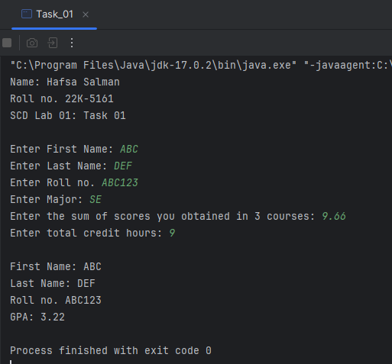

**Task no. 02**

**Task no. 03**

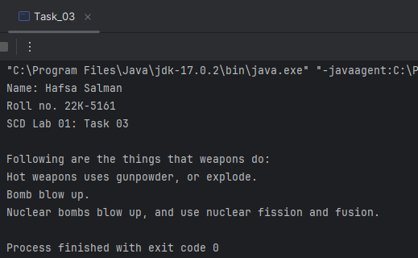

**Task no. 04**

